Cycle7
experiment1
aim

sourcecode

def read_file_into_list(filename):
with open(filename, 'r') as file:
lines = file.readlines()
return [line.strip() for line in lines]

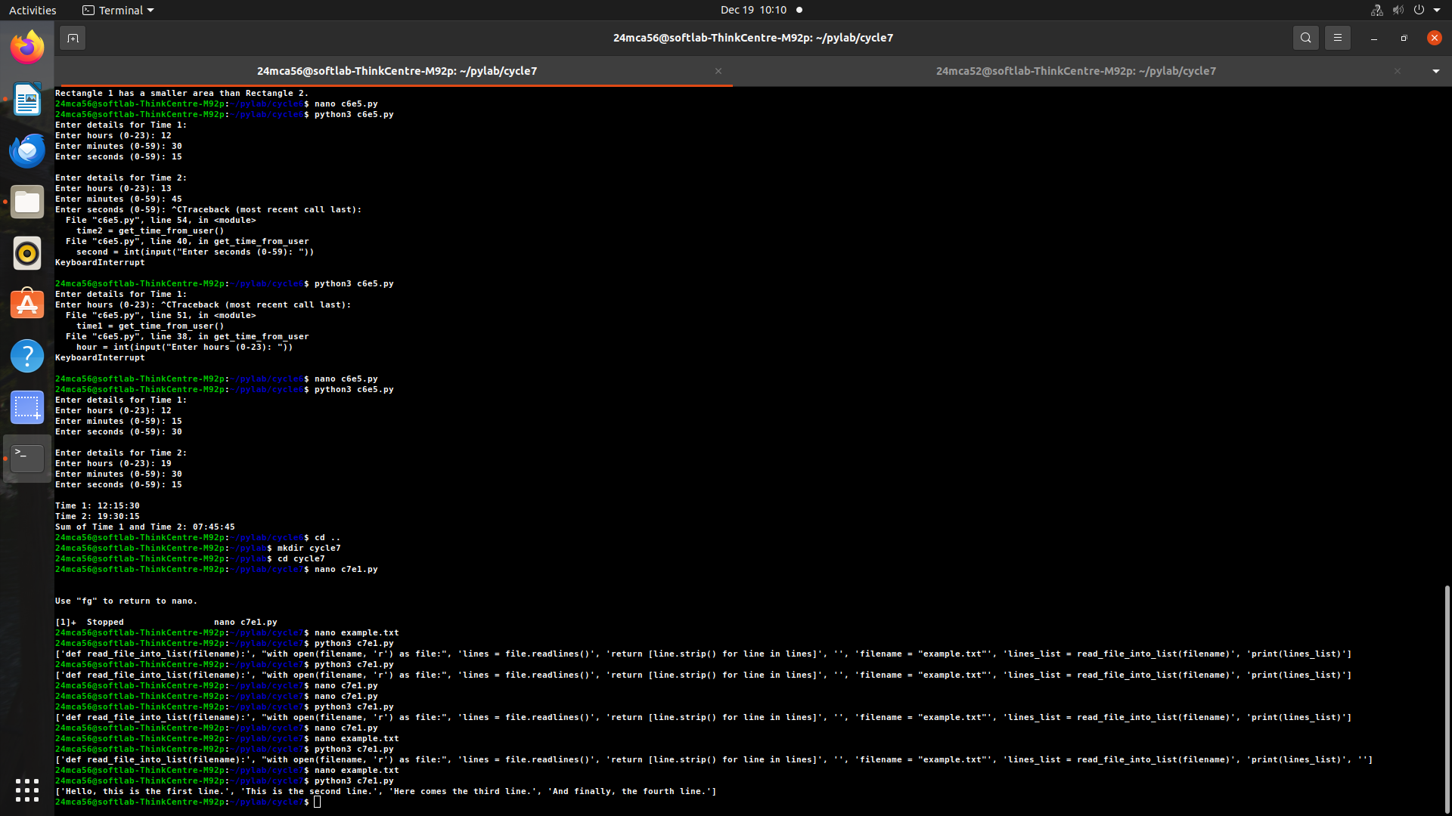
filename = "example.txt"
lines_list = read_file_into_list(filename)
print(lines_list)

experiment2
aim

sourcecode
def copy_odd_lines(source_file, destination_file):
with open(source_file, 'r') as src:
lines = src.readlines()
with open(destination_file, 'w') as dest:
for i in range(0, len(lines), 2):
dest.write(lines[i])

source = "example.txt"
destination = "odd_lines.txt"
copy_odd_lines(source, destination)
print("Odd lines have been copied.")

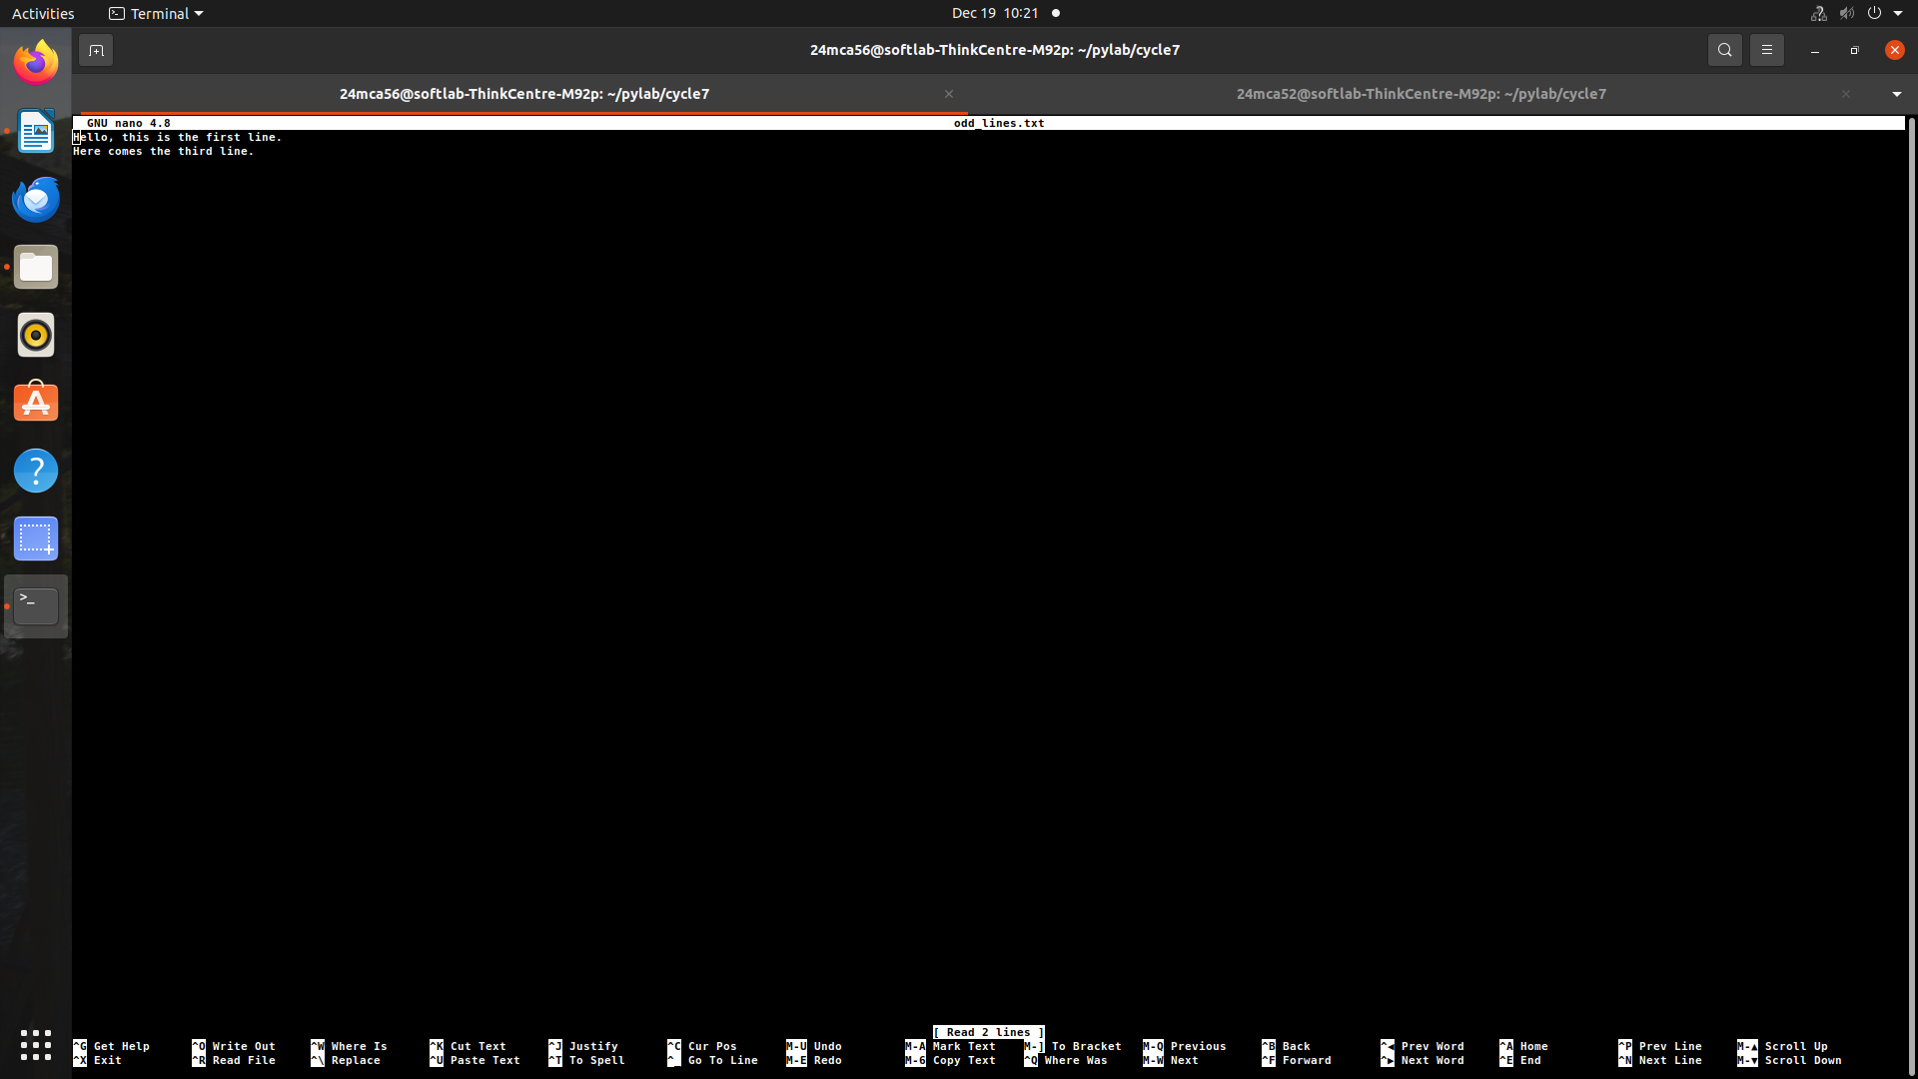

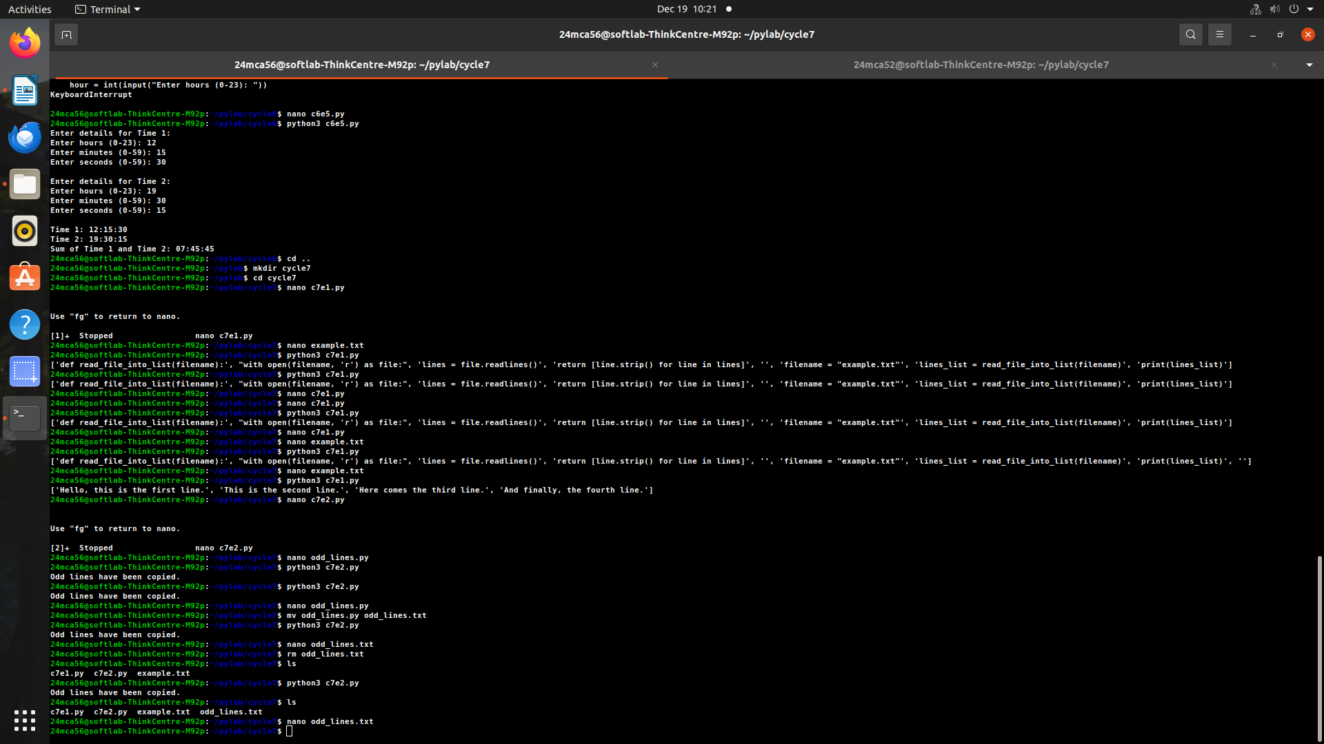
experiment3
aim

sourcecode
import csv

def read_csv_file(filename):
with open(filename, mode='r', newline='') as file:
reader = csv.reader(file)
for row in reader:
print(row)

csv_filename = "example.csv"
read_csv_file(csv_filename)

example.csv
Hello, this is the first line.
This is the second line.
Here comes the third line.
And finally, the fourth line.
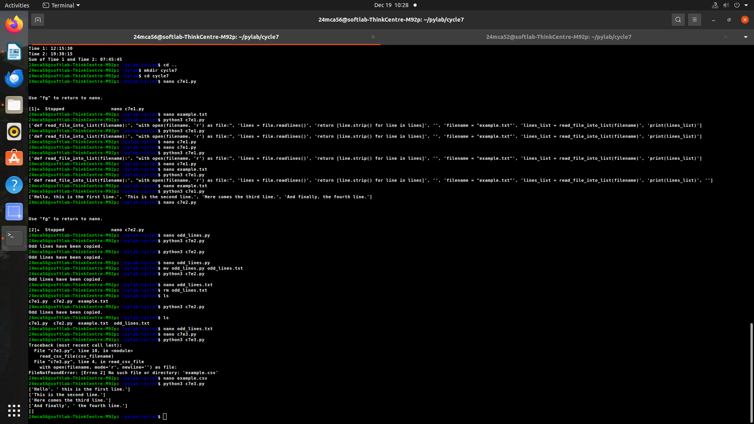

experiment4
aim

sourcecode
import csv

def read_specific_columns(filename, columns):
with open(filename, mode='r', newline='') as file:
reader = csv.reader(file)
for row in reader:
try:
selected_columns = [row[i] for i in columns]
print(selected_columns)
except IndexError:
print("Error: One of the specified column indices is out of range.")

csv_filename = "data.csv"
columns_to_read = [0, 2]
read_specific_columns(csv_filename, columns_to_read)
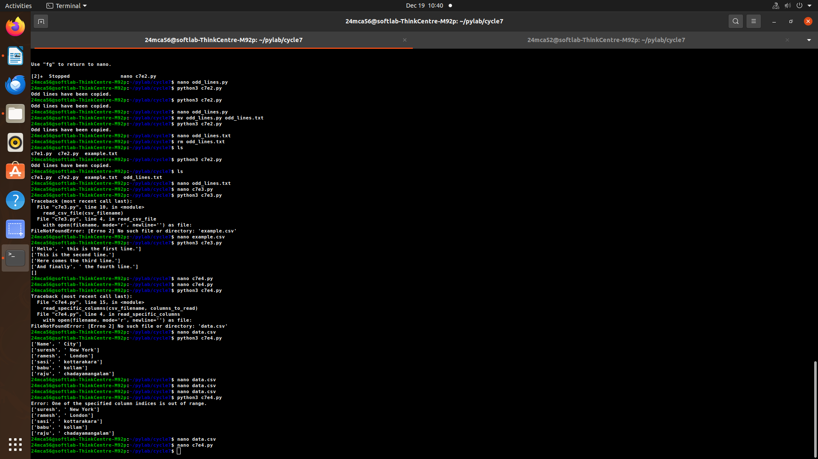

experiment5
aim

sourcecode
import csv

def write_dict_to_csv(filename, data):
with open(filename, mode='w', newline='') as file:
writer = csv.DictWriter(file, fieldnames=data[0].keys())
writer.writeheader()
writer.writerows(data)

def read_csv_file(filename):
with open(filename, mode='r', newline='') as file:
reader = csv.DictReader(file)
for row in reader:
print(row)

dict_data = [
{'Name': 'John', 'Age': 28, 'City': 'New York'},
{'Name': 'Anna', 'Age': 22, 'City': 'London'},
{'Name': 'Peter', 'Age': 34, 'City': 'Berlin'}
]
csv_filename = "output.csv"

write_dict_to_csv(csv_filename, dict_data)
print("Data has been written to the CSV file.")

print("CSV file content:")
read_csv_file(csv_filename)
